PartIIIB
Local Metric quantization
Review Recall from partIIIA that the fundamental equation of metric quantization is g_{oo}=κ_{oo}.
Also we have the usual centripetal force for circular motion around the galaxy: mv²/r=GMm/r² . So GM/r=v². So after taking the real part (cos) of e^{iΔε} (=1-Δε²/2) we get from all these equations after doing the algebra (i.e., cancel the m,r, get GM/r=v² and plug into realg_{oo}=realκ_{oo} so that 1-(2GM/rc²)=1-(Δε/(2(1-2ε))²/2 so 2v²/c²=(Δε/(2(1-2ε))²/2, v=cΔε/(2(1-2ε)) (11.3)
Also v=(Δε/(1−2ε))c/2 so v/c=constant. (11.3a)
Local metric quantization is ubiquitous. We see it in the mesocyclones above tornados, in hurricanes delineating their 45mi/hour rotational speed jumps, in Saturn’s rings,in the solar system keeping the orbits stable so the evolution of life has time to happen. in the sun, in spark gaps, even in the twinkling of the stars. Yet this massive amount of local metric quantization phenomenology is ignored.
12.2 Direct Measurements For Local Metric Quantization Are Possible
The sun moves 11m/sec at aphelion and 12m/sec at perihelion relative to the COM. But for 10m/sec with the next lower metric quantization 10cm/sec. But the difference between aphelion and perihelion is 12-11=1m/sec metric quantization and we only have 5 jumps (as seen on the 307A graph) for stable 20cm/sec metric quantization in the plasma tube. Note below the plasma tube has those two HeII lines plus that cyclotron motion frequency giving the 3 lines required to make the plasma tube a laser.
Solar cycle is proportional to rate of fusion. The rate of fusion is proportional to T¹⁷. for CNO stars. For the PP fusion in the sun it is proportional to T⁴. T in the sun is a function of the isostatic equilibrium of gravity pull and thermal energy pressure. Thus a small change in gravity(here metric) gives a small change in solar activity. Planetary tidal effects given by ΣF_{i}|cosθ_{i}|=re give short term solar activity cycle because a diffusion charge layer exists on the sun (due differential diffusion of protons and electrons). Amperes law currents and B fields are then modified and through Fick’s law the rate of energy diffusion out of the sun is then modified.
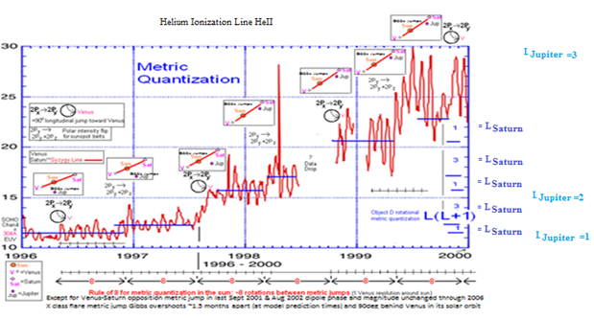
1000 P | 303.7804 | He II | MK00b
500 P | 303.7858 | He II | MK00b
10 | 320.293 | He I | TW71
2 | 505.50035 | He I | M02
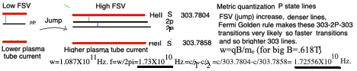
Fig.3

He II and 40cm/sec Metric Quantization jumps
From observed Zeeman effect in sunspots can assume B=1T in the plasma tube. Then the cyclotron frequency ω=qB/m_{e}= (1.602X10⁻¹⁹)1/9.11X10 ⁻³¹=1.758X10¹¹ Hz.
f=ω/2π= 1.758X10¹¹/2π=f=2.79875X10¹⁰Hz.
For the two 303$\dot{A}$ spectral lines:
Δf=f₂-f₁= c/λ₁-c/λ₂ =c/303.7804-c/303.7858= 9.867879X10¹⁵-9.86855X10¹⁵= 6.6844362X10¹¹Hz.=Δf. ω=2πΔf-4.2X10¹² Hz
f_{HeII}/f_{cy}=6.6844362X10¹¹/2 .79875X10¹⁰=23.88. So the jump to the cyclotron frequency is about 1/24 th the jump from f₁=c/λ₁ to f₂=c/λ₂. f= 2.79875X10¹⁰Hz. The λ₁ line can then directly lose a photon to the λ₂ line through the fast jumps cyclotron frequency Bremsstrahlung photon cyclotron frequency f=2.79875X10¹⁰Hz=cyclotron frequency even though the transition directly between the two spectral lines is prohibited (since they are different P states). Also

3P spin plasma tube state quadrilateral geometry(normally just 2P_{i} dipole geometry) results if 303A goes up and rest of spectral lines go down.
Infrequently the 303A HeII line with those 40cm/sec metric quantization jumps increases when all the other wavelengths energies are decreasing the metric quantization Hund’s rule changes and so the states fill differently. So there is a temporary jump to a 3D excited state with quadrilateral plasma tube geometry (Not the usual 2P_{x} ,2P_{y}, 2P_{z} metric quantization states) so the response dynamics to the tidal forces (eg.,convexity changed to linearity and vice versa) and so in the fortran output min are max and max are min., at least temporarily.

The 40cm/sec metric quantization jumps in the plasma tube raise the energy and so current I and so B field (B=μ_{o}I/2πr) in the plasma tube mv²/r=qvB energy in steps between 0 and 10m/sec and get the cyclotron frequency closer to the c/λ₁-c/λ₂, frequency. So the upper energy difference is smaller making the transitions more rapid according to Fermi Golden rule. This occurs in those Heaveside steps. This is analogous to the jumps to the next energy level in a helium neon laser with electrical current rise. A jump in modes mean, from Fermi’s Golden rule, a lower FSV and so higher rate of energy level jumps between the two 303A lines given this intermediate allowed line and so a brighter HeII 303.7858$\dot{A}$=λ₂ line. Thus the HeII lines jump in intensity like a Heaviside function at metric 40cm/sec quantization jumps. Other spectral lines don’t do this. This is actually an increase in transparency since HeII also is the cause of the opacity of the photosphere. The plasma tube is jumping 40cm/sec metric quantization as Jupiter proceeds in its orbit toward or away from perihelion. Venus cancels Saturn temporarily and the(plasma tube) laser is pumped and out comes a flare.
According to the Einstein A and B coefficients you need this third level (cyclotron frequency) to have a laser. The plasma tube turns into a laser man! The closeness of these 303$\dot{A}$ energy levels(the difference is the cyclotron frequency) also explains the sensitivity to planetary motion.
n_{i}=(ρ/1)N_{A} for protons. But electron mass is used both in the conductivity and plasma frequency.
Electrical conductivity =σ=n_{i}e²/(m_{e}f).
η=1/(μ₀σ₀)
S =μ_{o}LV_{A}/η , with L the diameter of the convection cell. Note they tend to be split in two.
v_{in}/v_{alfven} =1/√S. Solve for L
L=Diameter=1,468km. Actual is 1,500km.
So the granulations is caused by metric quantization and magnetic recombination in the convection zone. Who would have thought that these 1500km wide granulations are metric quantized! Recombination at a granulation must be periodic creating the BP magnetic reversals seen in the solar wind.
Note if you replace the metric quantization vin=1km/sec with the metric quantization 100km/sec=vin in the same location in the photosphere you get yet another L =1.468m in diameter granulation. Given the huge vin (100km/sec rms corresponding to 1.3MillionK) they are the source of microflares, that feed the corona with energy! I know there is long literature on microflares
Here the core of that new algorithm is v_{in}=1km/sec is replaced with 100km/sec, the respective. metric quantization speeds. These microflares are so narrow (1.5m) we can't resolve them from earth. They would occur at the edges of these much larger convection cells and be detected by a rf line in the solar spectrum at 4Mhz

The Quantum Mechanics of the Transitions Between Metric Quantization Lines and Ordinary E&M Quantization. Lines
So where does this other hidden metric jump quantization energy go since optically we cannot detect it?
I did a computation of that quantity and surprisingly curlv terms at. distance come out. They are very high frequency and so may elude your run of the mill small gravitometer but not a large body or gaseous matter, (eg.,hurricanes on earth). or the large LIGO before they put in the crackle filters.
Recall the HeII (helium 2) line. If the speeds jump in metric quantized units in the plasma tube the intensity of the upper line separated by the cyclotron frequency 17.25 Gighz will jump also since the temperature and so free energy around the plasma tube thereby jumps. We use mw^2r=evB so evB/(mw^2)=r here (also need .5mv²=3/2kT to solve for v in terms of T). It lifts electrons, just as happens in a laser, from a stable state to a metastable state where transitions to ground occur rapidly due to spontaneous emission here and so you get a brighter 303 line at metric quantization jumps because the v and so the temperature jumped. So higher temperature and so more photons are involved. The effect of the Hell line jumping in intensity with metric quantization jumps is then similar to the functioning of a laser! Note the temperature in the plasma tube has to jump also with the v.
The metric quantization of the sun's gravity (seen in those EUV metric jumps) is due to a huge electron at 10¹⁶ LY “Bohr radius” orbiting that proton containing objects A (i.e,. our own "universe"), object B (responsible for the galaxy halo metric quantization and farther away object C.
An electron at this (huge) Bohr orbit does numerically give thecorrect metric quantization seen in the (above) solar EUV data and is consistent with the 5 minute solar oscillation resonance as well. Thus the ratio of the frequencies: 2.7My/1monthmin≈10¹⁰, ratio of the Fdx energies: 1/10⁻¹⁵)² dx/1/(10 ⁻¹⁰) ²dx/≈10 ¹⁰
The period of oscillation of those supermassive and massive black holes in the same way (section 23.7) is in resonance with the ε(250my) and Δε (2.7my) metric jump times respectively. Recall the Δε metric contribution gives the galaxy halo quantization, the numbers work out extremely well also (section 23.4, that 87km/sec beautiful halo velocity result). Note here for superluminal motion the relationship between energy and velocity and frequency is reciprocal of the usual relationship. So for v>>c in the dr/o extrema superluminal regime (of section 1.1) :

$E=mc^{2}=\frac{im_{0}c^{2}}{\sqrt{1-\frac{v^{2}}{c^{2}}}}≈\frac{im_{0}c^{2}}{i\frac{v}{c}}=\frac{m_{0}c^{3}}{v}=\frac{m_{0}c^{3}}{ωr_{H}}$So that energy changes are proportional to 1/ω. Thus for superluminal motion the higher the velocity and higher the frequency the smaller the energy, in contrast to standard quantum mechanics that has the usual relationship between energy and frequency. Thus the ε and Δε metric jumps are much larger and with a larger period than the metric jumps giving the solar gravity metric changes due to that “electron” motion at the (10¹⁶ LY) Bohr radius of our object A,B and C proton we are inside of (recall we are inside the object A electron).
This is exciting stuff, probing another (fractal) atomic physics on a 10¹⁶ light year scale. by simply observing the EUV stair steps over the duration of a solar cycle (see above figure).
The compressed big bang object behaves like a water drop the same as the nucleus does.as we mentioned in chapter 2. The speed of the superluminal changes (or the speed of sound for that matter) is greater then the expansion rate when the object is completely compressed. The small Δε oscillation is a L=100,000 spherical harmonic on top of the fundamental oscillation giving the cbr power spectrum and is the large void regions observed in the present universe. The object D electron has an even higher frequency and so smaller superluminal effect and is responsible for a L=10¹⁰ harmonic and so is the origin of the galaxy substructure of the universe.
In quantum mechanics the particle states such as energy and angular momentum are quantized in bounded systems. In this fractal physics we ‘inside’ those particles so this translates into a quantization of what the particle is made of, the metric itself.

Metric Quantization in Neutron Stars
It appears that the interiors of neutron stars are also metric quantized. The deep interior is a superfluid quantum vortex of metric quantized P states with spin 1/2 Dirac substates and the shallow layer is a spin 1 (Bosonic) S state connected to the interior through boojums.
I have seen metric quantization everywhere it should be (ie.,where there is a grand canonical ensemble with nonzero chemical potential) and in that regard see no reason that metric quantization cannot exist in neutron stars
12.2 ε,Δε Metric Dispersion Relation In the Gravity Wave Equation For r<r_{H}
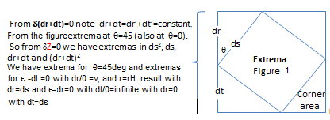
From the figure ε-dt≡0. So dr/dt=dr/0 makes metric quantization propagation effectively instantaneous. See figure 23-11 for an example. The other extrema implies ε-dr =0. So for r<r_{H} this is an extrema at the center r=0. Recall the plus sign in r=r_{o}(1--e^{±kt}) for motion back to the central extrema. Note the axis of evil gives a hint of this second extrema at r=0.
Recall that regard recall we found that the minimal 45° extrema of δds=0 in figure 1-1 (with dr+dt=ds√2) also gave us our ordinary relativity and our new pde. But there are observable consequences of the other two extrema conditions of figure 1-1 as well. For example in moving from a position of that minima 45° extrema of δds=0 to the maxima extrema dr/dt=∞ you must pass through a horizon r_{H} as mentioned in the mathematical induction part of section 1.4. Thus those quantized motion effects (e.g.,rotational quantum number changes for objects B and C) reach the inside of r_{H} nearly instantaneously. For example in the gravity wave equation there is that usual 1/c² denominator factor in front of the second time derivative so we have speed c. But to include the ambient metric r=r_{o}sinhωt repulsive component however we must include the ambient metric factor (1+2GM/c²r)c²≡(c²+(ωr_{H})²) for the metric cosmological expansion (repulsion). This equation essentially is a dispersion relation in the gravity wave wave equation since in the usual gravity wave derivation this new component ends up in the wave equation denominator as a coefficient of the time component dt². Note for the universe GM≈10⁵⁵(mks), r≈10²⁵m so (1+2GM/c²r)c²≈c²+v²=10¹⁶+10³⁰ giving a dispersion relation speed v of several billion c. Note ordinary GR gravity does not contain this repulsive component. Thus metric changes move across the universe instantly while weak gravity (as well as ordinary E&M) waves move at the speed of light. Thus a metric change event is first observed locally and then is later observed at some large distance, even though the event occurred simultaneously at all these points.
As an example the observable consequences (e.g., increased star formation in the great wall ) appear to propagate away from any given location at the speed of light in a steadily expanding shell. Thus the observed metric quantization jump boundaries must move away from us. So there must be a periodic rapid decrease in the ambient metric coefficients because of those object B and C quantum jumps. In that regard recall just the quantization of the Δε red shift in units of observed 75km/sec. That Δε and ε lead to a 75km/sec and (ε/Δε)75km/sec =v_{q} =7345km/s quantization of the red shift(calculation above). c/v_{q}=13billion/x leads to x=3.1million (for the Δε substitution) and for the ε/2 substitution we get 310million year interval in time between major metric changes(actual 290MY)
along with the above object C 1/3 split. Recall from equation 9.23 (N=0 is `the case of constant psi in inside r=r_{H}) that E∝∫∑_{n=0}sin((2n+1)ωt)/(2n+1)dt for both ε and Δε separately. (12.2)
Thus there is an associated Gibbs overshoot phenomena. Now when the metric changes like this the very properties of mass have to change. See figure 1.for ε changes (red lines). Note you should see greater star formation in such a metric shift region at the upper overshoot, stars about 600mY light years away from us. In fact this is seen. It is called the Sloan and Geller great wallsof galaxies.

The (small) Δε quantized metric effect is washed out (in 2df and Sloan surveys) by random galaxy gravitational interactions (except in the halos of stable spirals, section 11.4) but the ε quantization is too large to be washed out here. Thus the triplet ε quantization (due to object C) is seen in the red shift surveys, is the light blue curved lines in figure 2. Note the metric change is nearly instantaneous over the whole cosmos which is an example of the dt=0, dr=large extrema of ds giving a phase change in equation 4.2 in κ_{oo}=e^{i(-2ε+Δε)} since it is a ordinary time dependent quantum jump as seen at r>r_{H}. This is a QM phase propagation contribution inside this exponent in κ_{oo}, not a group velocity, so no energy is being propagated across this object at these dr/dt≈10⁴⁰c velocities (explaining fast gravity contribution at least as seen locally). One analogy would be a light bulb turned on inside a spherical room illuminating all parts of the room simultaneously. The observable effects (e.g., more rapid star formation at the eq.22.1 Gibbs phenomena jump) however do propagate outward at c giving the appearance of a spherical shell around our particular location as in, great walls in 2df survey, etc.,. All x,y,z points would then experience this same illusion of being at the center.
One interesting consequence is that the huge scale outside observer sees this 10⁴⁰Xc phase velocity as a real, very near c, velocity, with resulting huge Fitzgerald contraction. If his clock runs the same rate as ours he sees this (10⁴⁰ times larger) universe to be as small as we seeours. So the universes are all observed to be the same size at all fractal scales!
Given this same size there truly is then only ONE observable object (given by that new pde, equation 2) as in equation 4.14.
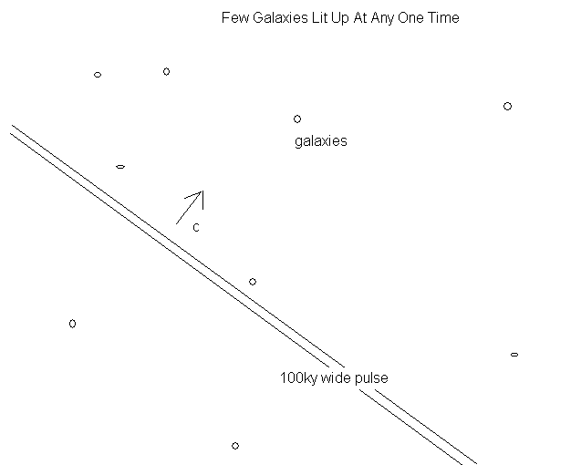
Note that outside r_{H} we use the standard Dirac equation operator - eigenvalue formalism. Let's say we solve the Schrodinger equation (a nonrelativistic limit of the Dirac equation that equals /2m)d²ψ/dx²+Vψ=Eψ) for eigenfunctions ψ. We then do the eigenvalue= ∫ψ*OPψdV =expectation value where OP is a typical quantum mechanical OPerator such as energy (H) or angular momentum (L) for which we apply the operator formalism p_{x}ψ=-i(dψ/dx) also. As an example recall that the Hamiltonian H is the time development operator Hψ=-idψ/dt. Here (e^{iHt})ψ=OPψ. Note the time development assumes the Dirac particle is a point, so that the change in state happens over the whole particle all at once even if you approximated it to be a "small" point.
So what happens inside r_{H}? The same thing! The change in energy level for example due to the outside dynamics happens over the whole particle all at once. Also inside r<r_{H} we have that dt=dt_{o}√(1-r_{H}/r) is imaginary so the time development operator is not oscillatory anymore, gives decay e^{Ht} attenuation. The metric inside is also the same H as the outside H but given the energy level changes with this e^{Ht} attenuation we then go through the
sequence of energy level changes of the outside state! Note we have not assumed a superluminal movement of the metric quantization change here. We have just applied the outside r_{H} quantum mechanics to the inside r_{H}.
So what does the outside observer infer for the inside region QM operator changes? The dt'=dt_{o}√(1-r_{H}/r) =0 for r=r_{H} so that dr/dt' = infinity for inside propagation from his frame of reference. Thus there is Gibbs effect attenuation of the square wave higher frequencies.
In any case the inside observer need not worry about superluminal propagation of metric changes: you simply apply the outside quantum mechanics self consistently to the inside and find that the inside r_{H} metric jump changes occur all at once.
SHM States caused By object B
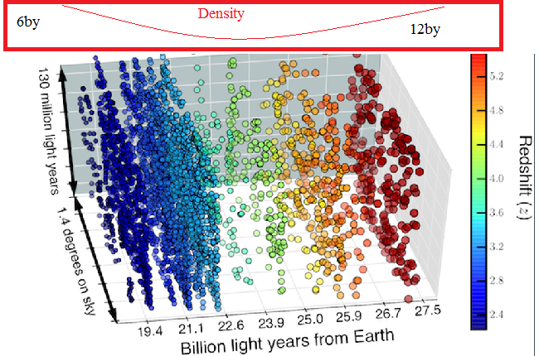
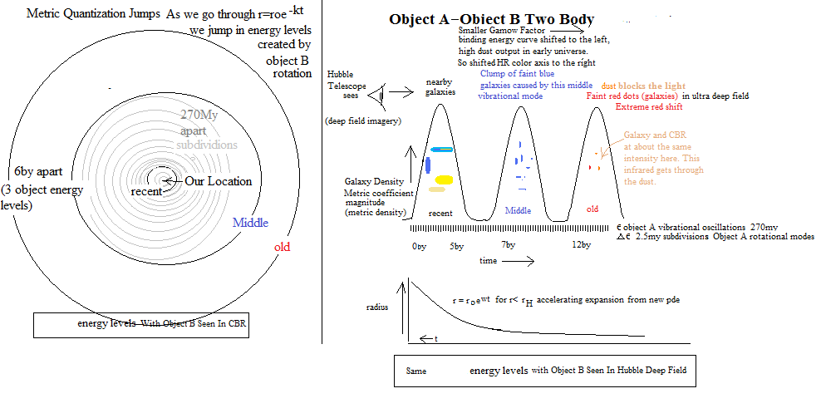
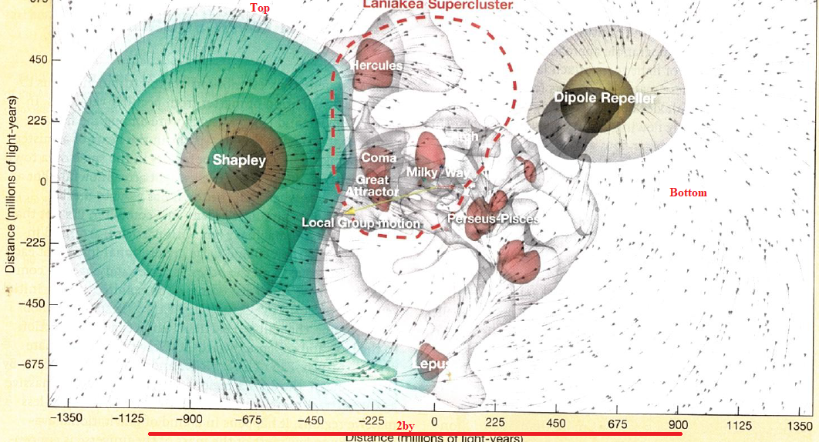

Fig.5 Noam Lebeskind. The Shapely concentration is the compressional part and the dipole
repeller the expansion part of that 6by vibrational wave from object B. The Shapely concentration is the compressional peak of the 6by wave and the great void of Eridanus the rarefaction low of that wave. The 270My oscillations are the smaller voids. The 2.5My oscillations are the key to understanding the scale of galaxy formation
Note the vibration eigenfunction above right. The rotational was the ε which the great walls of the many voids. When the outside observer sees the contraction starting the inside (r<rH) must begin contraction also so the sign of w in r=r_{o}e^{wt} for the interior observer must change. Thus the red shifts change to blue shifts at this time. Object B is ultrarelativistic with respect to object A so it has a much higher observed zitterbewegung frequency. So object Bs zitterbewegung oscillation frequency is seen to much higher than object A s frequency. Object C gives same zitterbewegung period as object A so not observed separately. Object C gives that 2.5My metric jump (Ch.23) due to moving through rotational eigenstates. There is one object B metric jump period every 6by and so 60 such oscillations in the past 370by. So (1/3)1836≈600; 600/60=10 and so 10X370=3.7≈ 4 Trillion years before our own contraction, when the red shifts change to blue shifts.
Note there are three motions going on at once here. The first motion is the r=r_{o}e^{kt} object A zitterbewegung expansion inside r<Compton wavelength (fractal-cosmological). This motion ends at r=r_{H} 4trillion years commoving time. The expansion then turns into a contraction. The second motion is that (above) 6by zitterbewegung oscillation of the object B plate superposed on top of that r=r_{o}e^{kt} expansion. This yields a peak of galaxy numbers at 6by and 12by. There is also a stair step (object B rotational quantum state) metric quantization effect at 270my with Gibbs jump down and jump up (freeze and then bake) of 100k years duration.
violating baryon conservation since from the fractal theory these objects originated from a previous collapse.
Perturbative Limit

The Bullet Cluster collision, Abell 520 collision and Galaxy cluster CL0024+17 collision gravitational lensing maps (Hubble space telescope) all illustrate the excited S states resulting from galaxy cluster collisions. Note the spherical 1S and 2S states that result.
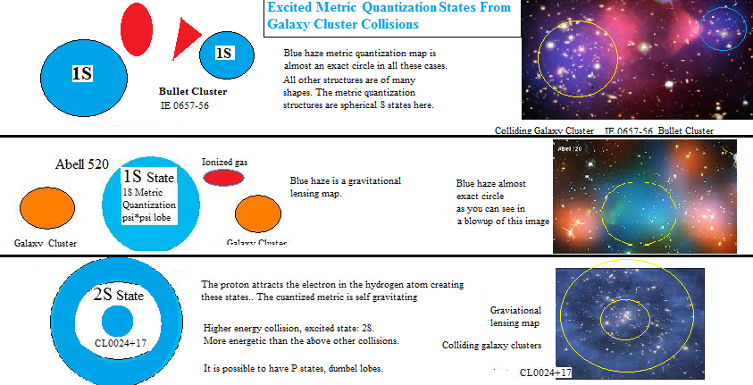
Fig.6
Gotta take a close look at the bullet cluster blue blobs: there are big clusters of galaxies inside each of those two blue blobs allowing you to set goo=koo on the edges making these metric quantization effects, not dark matter.
Also the central black hole of one or the other of one of these colliding galaxies would no longer be in resonance (next section) with the now new ambient metric and so it could suddenly “turn on” a jet to come to the correct equilibrium mass.
Also metric jumps out in the halo transition between galaxies would have the effect of clearing those regions of stars, especially of globular clusters. Also black hole jets would suddenly terminate at metric jump boundaries as apparently M87 s does. 1S sphere, 2S sphere-ring and sigma bond metric quantization between groups of galaxies exist also. This sigma bond metric quantization connection also explains the large strings of galaxies (in analogy with long molecules).
So we can set 2GM/rc²= Δε=to get the effective mass M that Δε represents at a galaxy halo distance r. But note that for centripetal force mv²/r=GMm/r² so that v²/c²=GM/rc² =Δε. Thus if Δε is constant so is v² which is seen in the flat parts, especially at large distances, of the curves in above figure 7. We can also compute v²/r at 60kLy and get (261km/s)²/60k ly=1.22X10⁻¹⁰ m/s² ≈1 Angstrom/s² (ala Mond who just adds this to ‘a’ in F=ma (Milgrom, 1983) which stays the same ratio at 15k ly which is set by the ω²r_{o}sinhωt equation (2nd time derivative of eq.1.11) acceleration of the universe. Local gravity sources are quantized as well as in 2Δε=v in a=v²/r goes up by 2vX2v/r=4v²/r= 4X1.2 A/m²=5A/m² which is the galaxy bulge and anomalous pioneer 10 & 11 accelerations (if that radioisotope thermoelectric solar sail effect is considered as well(which itself is 5A/m²).
Note as t increases and if n is finite (so Gibbs jumps) this function goes up in a stair step fashion with time with each Gibbs jump increasing the integral. These are the metric jumps giving the quantization of the redshift. Note that the galaxy hubs (including black holes) gravity jumps rapidly at jumps transmitting a pressure wave radially from the center. Thus star formation is more rapid at these locations. Also Hubble dark matter maps seem to show a constant density distribution more indicative of a quantized metric source of this effect than what seemingly random distributions of dark matter are capable of. So there is an enormous amount of evidence for a quantized metric and for there being NO DARK MATTER!!!

12.3 Metric Quantized Stable Quantum States
Case II Recall from the first part the result of mixing the states:
iεe^{-(Δε/ε)}=iε(1-(Δε/ε)+Δε²/ε²-Δε³/ε³-..) (13)
Note from equation 13 that the metric quantization mixed state is:
(|ε>+|Δε>)/√2≡|QM>,
But ε is a Fermionic state and Δε is a Fermionic state.
with the |QM> the singlet ↑↓ state with double the values of v.
given the Fiegenbaum point there is a slight helicity to the background metric since the Riemann surfaces from dz=dse^{iθ} are exact fractals at -√2 that puts a ε term in the ds² reparameterization equations thereby adding a tiny helicity onto the object B ambient metric. Having two such opposite spin “S’ states however restores the spin 0 zero net energy to the vacuum. Recall the S states in QM are filled stable states, just as are the p states with their chemically stable Nobel gases.
So the most stable |QM> state is
100km/sec -> 200km/sec (majority of galaxy halos) ↑↓ S state
1km/sec -> 2km/sec (the sun’s equator) ↑↓ S state 10m/sec -> 20m/sec (Mesocyclonic and other..) ↑↓ S state
So the spin 2 metric background metric has a spin ½ component that cancels in most cases to a singlet and so allows classical General Relativity (GR) theory to work.
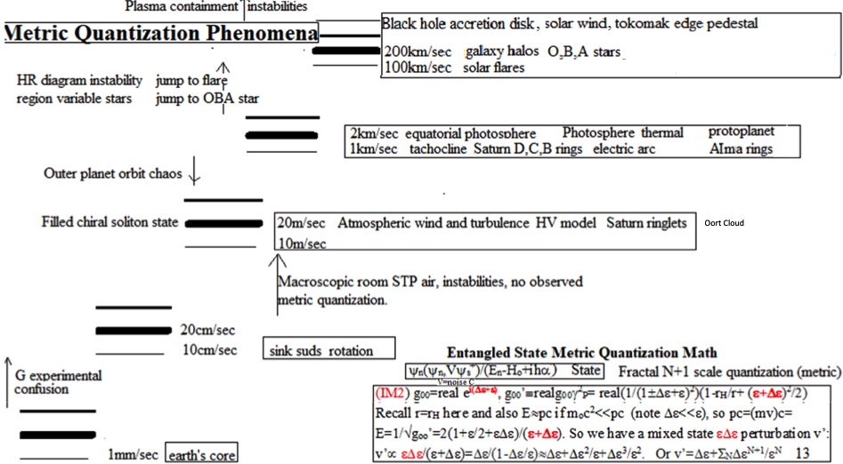
Fig.7
But spin2 means another “pedestal” of stability ↑↑↑↑ implied by GR itself so that 4(100km/sec) is yet another stable level, See DIII QDB tokomak result below.

Laboratory Measurements Of Metric Quantization
If you run an electric arc at very high amperage you get an ordinary Maxwell Boltzman distribution for the output molecular speeds. Note the envelope of the graphs below are approximately Maxwell Boltzman. But if you lower the current to the point the arc is just about to go out (Here below at 100Amp) you find that these interesting energy levels show up. Note the abscissa is in eV so I had to obtain v by setting delta(eV)X(1.6X10⁻¹⁹)=(1/2)mv² where m=MWmp=MW1.67X10⁻²⁷ and MW stands for the Molecular Weight.and delta(eV) means the difference in eV from peak to peak.I had to use the molecular weight of silver and zinc to find those velocity intervals.
Recall the 1km/sec represents stability regions in my metric quantization theory..
“In as much as the current stabilizes the arc, it can be assumed that the energy distribution of the ions is connected with the instabilities of the arc”
The same can be said for the “stabilities of the arc”.
Maximum speed of LS was 1km/sec. LS is brass.
271828

Soviet Physics,JETP, Vol.20, No.2, February 1965, Plyutto
High Speed Plasma Stream In Plasma Arcs
Note you have the same separation in velocities for both zinc(Zn) and silver(Ag) .
But silver and zinc have different quantum energy levels and so clearly this 1km/sec effect is not associated with their energy levels, it is something more universal. Recall we also see a N100km/sec effect in tokomaks.(there N=3)
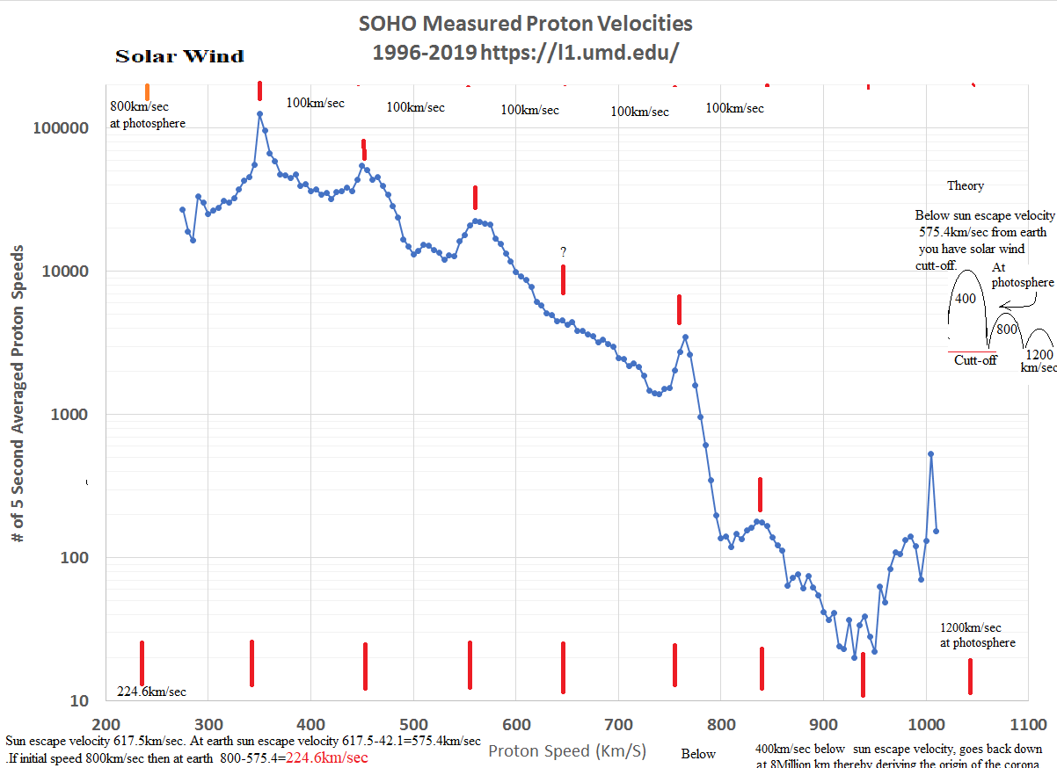
Fig.8You probably are wondering why you can't observe metric quantization in your living room for example given that the air in it is also a grand canonical ensemble. The reason is that the next lower metric quantization speed is 20m/sec which for liquid helium4 gives us 0.065K which is difficult to observe (room temperature is around 300K). Helium4 is the only material still liquid at these temperatures and so it can still be in a grand canonical ensemble.

You could ask why this metric quantization velocity "impeding" effect is not seen in accelerators as some new kind of 'impedance' or something as they are ramping up the speed of the particle. First of all in relativity velocity is relative so we must specify a COM frame as we do in quantum mechanics where we have the usual quantized KE energies (eg.,1/N² Rydberg energies) and so v=√[(2/m)KE)] “quantized” average velocities as well. Secondly the quantization levels fizzle out for masses much smaller than the sun’s mass (eg.earth). Also as we move in the earth’ orbit and rotate as well so no such velocity will be easily observable anyway. Most importantly the conservation of energy must be used. So if in a natural system (such as at the tachocline) there are several types of energy the velocity will be held constant and the energy transfered to one of the other types as in that tachocline example. Note you then still conserve energy. In the accelerator on the other hand you have only that accelerating energy so to conserve energy the particle must move right through the metric quantization velocity as though it was not there. The same applies to space craft motion. In these high temperature laboratory plasmas the effect would most certainly be in the noise in comparison to all the chaotic instabilities. The velocity quantization is in fact nearly all smeared out in the hubs of galaxies due to the many surrounding mass perturbations. A 2014 edition of
Physics Today magazine said that the value of Newton’s gravitational constant G is currently only known to 3 significant figures (somewhere between 6.672 and 6.676 X10⁻¹¹Nm²/kg²), really no significant advance beyond what Cavendish himself measured in the 1700s and a typical experimental error the students would have gotten in one of the many physics labs I used to teach! The problem is not in the experiments themselves which are accurate to around 20ppm-40ppm (even given torsion calculation uncertainties). The problem is in the spread of the results of these several very accurate, precise experiments.
In my view metric quantization is the problem here especially with the experiments that require a moving oscillating torsion bar to measure the torsion constant, where we can then have a grand canonical ensemble with nonzero chemical potential (as in Saturn’s rings), the requirement for that metric quantization to effect relative speeds and here mess up the torsion constant calculation and therefore the G calculation. By the way the new experiments, with no such motion requirement (e.g.,floating the balls in mercury), will probably finally nail down the gravitational constant.
Note that these pendulum speeds are far less than 20m/sec and so must be responding to much smaller metric quantization sources than object B, object C, object D and the Milky Way galaxy. The Sun and earth are the next likely candidates for even smaller metric quantization speeds, where we even go to the continuum limit (eg.,what about your desk?).

16.10 Red’s Law Of Metric Quantization
(1/π)^{2n} =velocity amplitude of metric quantization
(1/π)^{-2n} =time interval of metric quantization
n=0,1,2,3
velocity: n=1 v=20m/sec;. n=2 v=1km/sec; n=3 v=100km/sec, n=4 v=c/3
time interv n=1 100ky n=2 2.5my; n=3 270my n=4 4by
phenomena: cold cycles Pacific volcanic cycles Mass extinctions Dust
phenomena ringlets rings, sun convection zone great wall Faint blue galaxies HDF
phenomena ice ages chaotic Oort cloud galaxy halo speeds Faint red dots HDF
O,B,A rot, , coronal temp.
HDF =Hubble Deep Field
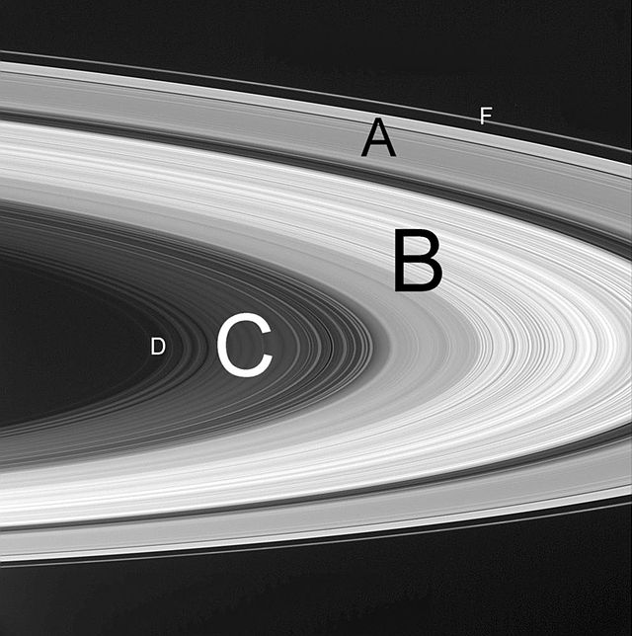
In the most detailed Cassini image of Saturn, there are 5 narrow rings, 8 2X widely spaced rings in the D ring: there are few shepherding moons here, the Roche limit will pull apart just about any big object here, You see two levels of metric quantization in the D ring. What an awesome sight, metric quantization in the raw, as explicit as it could be!!!
The speed of each consecutive inner ringlet increases by that 1km/sec (the outer D ring has 2km/sec metric quantization) of object C quantized metric value that also created Bode's law and the rotation of the sun's equator.
Also the velocity difference between perihelion and aphelion for the earth is .98km/sec very close to the metric quantization value, the key to its orbital stability, just as with those rings. This explains why there was enough time for life to establish itself on earth, so explains why we are here.
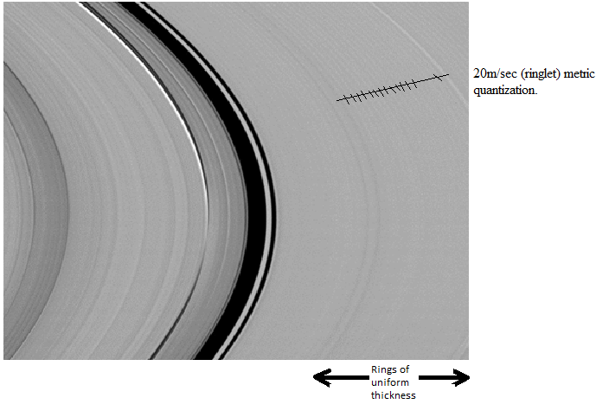
20m/sec ringlet quantization
1 km/sec differences be outer edge of D to C; C to B and B to A.
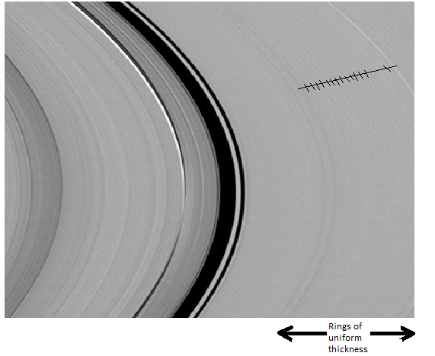
Close up Of Ringlets (20m/sec Metric Quantization
In a close up image of these small ringlets, visible in image, it is noted that
There appears to be no new subdivisions implying 20m/sec is the smallest metric quantization (after the 100km/sec, 1km/sec) and no smaller metric quantization exists. The neutron 2P ½ state electron at the poles of the 3 particles of the 2P3/2 state would have a plate interaction directly on it.
So this 20 m/sec must be caused by a more distant electron in orbit around this proton.
Thus we are in a isolated hydrogen atom in interstellar space.

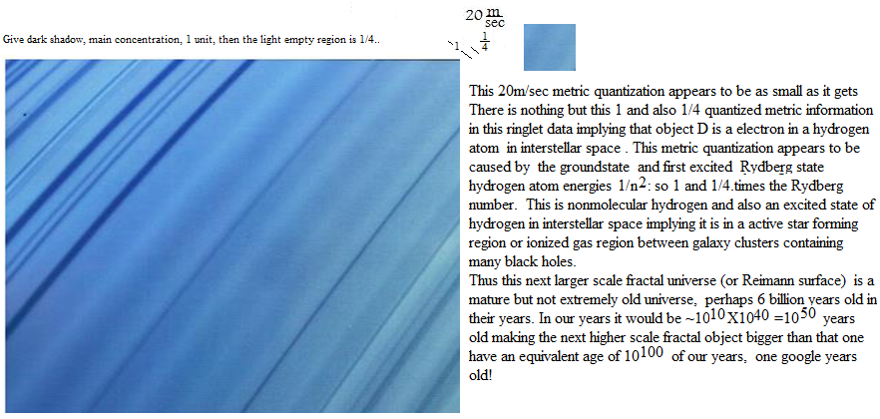 The Neptune metric is also quantized. The speed difference between the
57200 km and 55200 km rings for example is almost exactly 1km/sec.
The other ring is about twice that distance apart so twice the speed and so still metric quantized.
GMm/r²=mv²/r cancel the m and one of the r s get
GM/r=v² (1)
G=6.67X10⁻¹¹ N(m/kg)², M=1.024X10²⁶kg
So from r=55200km get from eq.1 11.1km/sec. For 57200km get 10.1km/sec.
The difference is 1km/sec, the metric quantization just like at Saturn rings.

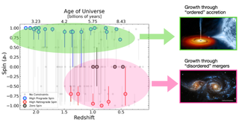
Black hole spins ard metric quantized at 400km/sec.
Appendix C
Recall the galaxy halo and O.B.A star 100km/sec (object B) and note the D ring 1km/sec, C ring 2km/sec and B ring 3km/sec (object C) implying a kind of Pauli exclusion principle to these metric quantization states. But note also a new ringlet 20m/sec metric quantization. caused by the Milky Way Galaxy gravity and/or object D.
Recall I found that a combination of the Jupiter movement in going from perihelion to aphelion (10m/sec) and Saturn 2X effect (10m/sec) is ~20m/sec to get the solar cycle.
Apparently the stability of Jupiter's and Saturn's orbits and therefore the solar cycle itself also depends on that (20m/sec) metric quantization!

1km/sec Metric Quantization In Protoplanet Dust Rings
Note for a solar mass star Neptune-Pluto is at N=3. Using that scale the outer ring is at N=1
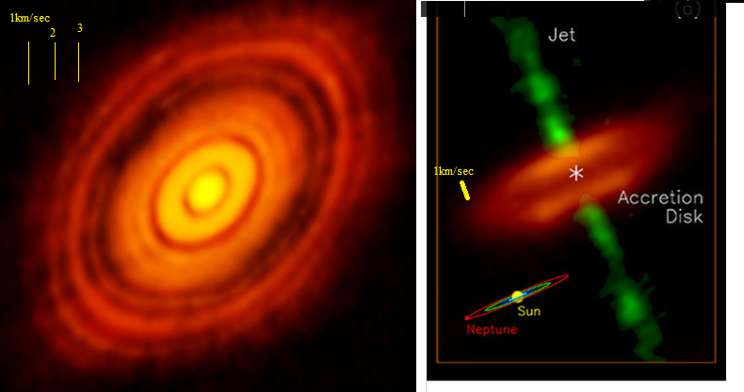

The 20m/sec metric quantization between the ringlets of Saturn. There may be yet another 20m/sec example of metric quantization closer to home. See below. 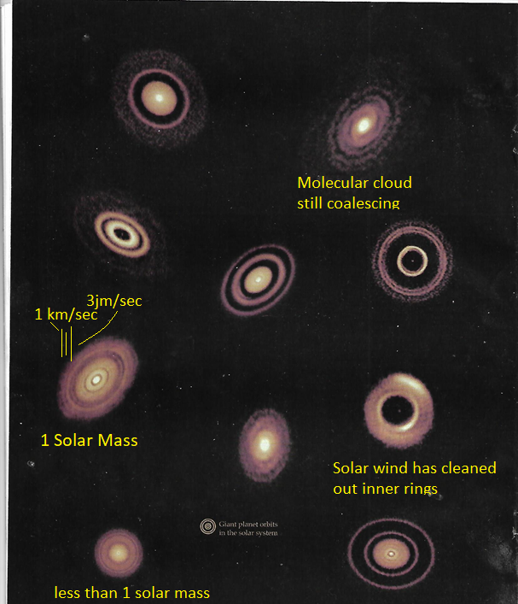

Alma images.

Recall from equation 13 (first attachment) there are those 100km/sec Δε, 1km/sec and 20m/sec metric quantization speeds. Recall from above that 20km/sec speed in those Saturn ringlets as a higher order term in my equation 13 for mixed states (i.e., grand canonical ensembles with nonzero chemical potential). Recall in equation 13 of the first attachment (section 1G of book) the 10meter/sec . Δε³/ε² metric quantization term.
In that regard from a recent ‘Physics Today’ article on tornado formation (1)
"On tornado outbreak days, the wind shear can be so severe that the winds can vary by as much as 20m/sec within the lowest 1 km". Also there is the statement in that article that for a supercell updraft , the vertical component of the vorticity, is on the order of 10⁻²/s"
∇Xv=curlv=2w=.01. So w=.01/2=.005=v/r. If v=20m.sec then r=20/.005=4km =approximate supercell radius (attachment image) If v=10m/sec the r=10/.005=2km.
Also in the below VORTEX2 Doppler data (below figure) the WHOLE right side and half the smaller left side exhibits a 20m/sec speed (the tornado is at coordinates (0,0)).
That 20m/sec value certainly has nontrivial implications for tornado formation. (1) What We Know and Don't Know About Tornado Formation" Physics Today, Sept.2014
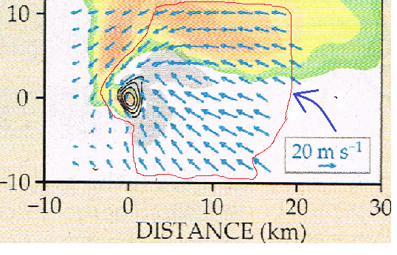

The lightning mapped out the metric quantization jump boundaries in Ian! In other words there is a radial speed discontinuity and so increased triboelectric physics going on there.
So there is the inner 135mph lightning (eye wall), the 90mph boundary lightning half way out and the (right) edge 45mph lightning
gives tornados their characteristic seismic signature that has even been used to locate their positions.
By the way the (above) tornado 20m/s metric quantization occurs in the accompanying mesocyclones (the huge cloud just above the tornado) and not in the vortex itself: can't get to 1000m/s with terrestrial air. 45mph=10m/sec. 10,20,30m/sec Metric quantization in canes: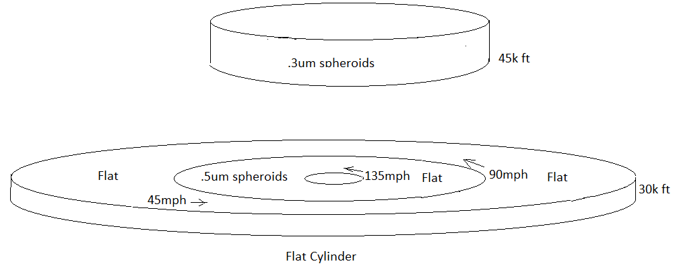

Metric Quantization In An Electric Arc
Recall metric quantization requires a grand canonical ensemble. A plasma moving in an electric arc can satisfy that criteria. In one experiment a 100Ampere silver (Ag) electric arc was produced. The apparatus had a device for measuring the distribution of ion energies inside the arc. Another experiment substituted zinc (Zn) instead in a 20Amp electric arc. If the metric was quantized at 1km/sec intervals stability regions of individual high streams in the arcs.in multiples of 1km/sec should be observed and they were.
Soviet Physics,JETP, Vol.20, No.2, February 1965, Plyutto
High Speed Plasma Stream In Plasma Arcs
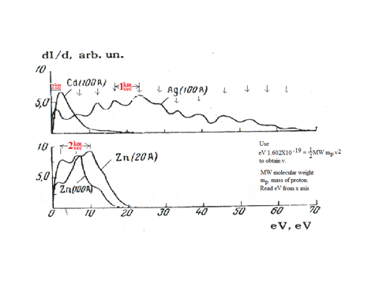
Recall the 1km/sec represent stability regions.
“In as much as the current stabilizes the arc, it can be assumed that the energy distribution of the ions is connected with the instabilities of the arc”
The same can be said for the “stabilities of the arc”.
Maximum speed of LS was 1km/sec. LS is brass.

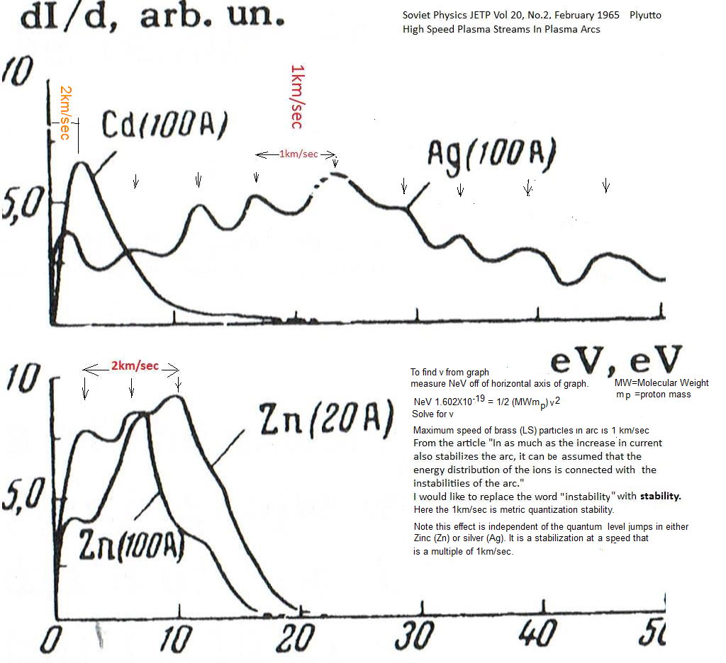
Note you have the same separation in velocities for both zinc(Zn) and silver(Ag) .
But silver and zinc have different energy levels and so clearly this 1km/sec effect is not associated with their energy levels, it is something more universal. Recall we also see a 100km/sec effect in tokomaks.
Large Gravity Constant measurement errors
In contrast if measurements of G were made at different laboratories at different separations the error bars in the measurements might not overlap because of this G quantization causing that well known large error in the gravitational constant G measurements.

Metric quantization gives a big change in climate. It has been said that Milankovich cycles change the climate
Despite the advances in computer modeling, there are still some puzzling questions about the Earth's changing climate and the Milankovitch cycles. Geological records show that up to one and a half million years ago, Earth's climate was changing with the periodicity of about 100,000 years, said Maliverno. Such fluctuations would be shorter cycle, of about 40,000 years, which would reflect the changes in Earth's obliquity, the tilt of its axis. What caused this sudden switch is a complete mystery.
"It doesn't make a lot of sense, because the eccentricity changes are so small, and the resulting changes in the sunlight are so small that we wouldn't expect it to happen," said Deitrick. "So some climate scientists have argued that the ice ages perhaps have nothing to do with Milankovitch cycles at all."
Miscellaneous and unrelated to metric quantization: Low gravity region centered on the southern tip of India.called IOGL. “The IOGL, as Pal and Ghosh argue in their latest paper, likely took its current shape roughly 20 million years ago “.It was caused by a meteor hit 17 million years ago in the Southern Indian ocean the sent a shock wave to the other side of earth to form the Columbia River basalt fissures in Northeastern Washington.
Sling shot anomaly metric quantization
Recall our mixed metric quantization states classically require a grand canonical ensemble with nonzero chemical potential, ie. exchange energy?
But what about the in-between case of the ballistic trajectory particles just beginning to interact with the other object (ie,. exchange energy) but not quite the full scale grand canonical ensemble with nonzero chemical potential as in Saturn's rings or that spark gap? A spacecraft flyby sling shot trajectory is such an in-between case. Well then, in that case we might start seeing a barely detectable (possibly not) bit of metric quantization, perhaps at 1mm/sec, 2mm/sec,. 4mm/sec ,.., 13mm/sec (fig7, attachment, bottom level), anomalous speed difference from the predicted one?
Hey, the Galileo spacecraft slingshot earth flyby got an anomalous 3.92mm/sec boost and the NEAR spacecraft flyby got a 13mm/sec boost.
Also from the mainstream:
"Anomaly appears to be dependent on the ratio between the spacecraft’s radial velocity and the speed of light, " i.e., v/c=constant.
eq.11.3 is a derivation of this result. Note there v=(Δε/(1−2ε))c/2 so v/c=constant.

12.4 Fractal Kerr metric implications Surprisingly tornados can do all this when they form: rotation, 511kV, no heat sink, metric quantization (45mph,90mph,..)
If we tried to build this same kind of vortex in a container the walls would act as a heat sink and so the GC would be lost and it wouldn't work.
Big Tokomaks do this already given their small heat sinks and that N400km/sec metric quantization(same as the solar wind) is seen in the big tokomaks. The problem is that any z direction forces might be confused with magnetic induction force effects in a Tokomak and there is no constant voltage of 511kV.
By the way the proton could exhibit a small z force(analogous to the 511kV rotator oscillator) that gives a small quadrupole moment to the deuteron, the neutron is slightly attracted to the z direction.
Postulate 0. Need small C’=SC_{M}/mc². Stable means m=m_{e}. As in composite 3e, r=rH for stability. Need quantization (flux pr metric) Need grand canonical nonzero chemical potential (but not with external heat sink) (as tornadoes, Saturn’s rings, tokomaks do)
Recall the M+1 cosmological fractal object has the usual GR horizon result r_{H}=2GM/c²
For the Mth scale fractal object r_{H} is 10⁴⁰ times smaller r_{H}2e²/(m_{e}c²). This r_{H}=2e²/(m_{e}c²). input also works in the new pde to get QED results. Note that
V=ke/r, r_{H}/r=(ke²/m_{e}c²/r=9X10⁹(1.6X10⁻¹⁹)²/[r9.11X10⁻³¹(3X10⁸)²]= (ke/r)(e/m_{e}c²) =V/511000.
Apply to rotations since an isotropic radial force from an artificial object will have no preferred direction. Rotations at least imply a specific axial z direction.
- ds² =ρ²[(dr²/Δ)+dθ²]+(r²+a²)sin²θdφ²-c²dt²+(2mr/ρ²)[asin²θdθ-cdt)² Kerr metric (applies to rotations) ρ²(r,θ)=r²+a²cos²θ, Δ(r)=r²-2mr+a².
Next convert to a quadratic equation in dt (Ax²+Bx+C=0 where x =dt. (organize into coefficients of dt and dt²). The Kerr metric is
ds²=ρ²[(dr²/Δ)+dθ²]+(r²+a²)sin²θdφ²+(2mr/ρ²)a²sin⁴θdθ²-[2(2mr/ρ²)asin²θdθcdt]-c²dt²(1-(2mr/ρ²) (1)
We avoid using the geodesic where Γ^{m}_{ij}≡(g^{km}/2)(∂g_{ik/}∂x^{j}+∂g_{jk/}∂x^{i}-∂g_{ij/}∂x^{k}).since they would require a mile long equation for off diagonal metrics) by just solving the Kerr metric as a quadratic equation in dt² and then solving for dz/dt (θ=90°) and then taking a time derivative. Write down A B and C in the respective quadratic equation:
A=c²(1-(2mr/ρ²), B=2(2mr/ρ²)acsin²θdθ, (''A" is set to zero by setting V=511kV)
C=-ds² +ρ²[(dr²/Δ)+dθ²]+(r²+a²)sin²θdφ²+(2mr/ρ²)a²sin⁴θdθ²
dt=[-B±√(B²-4AC)]/2A≈-B/A or 0 if A≈0. If also θ≈90° then ρ=r, Let a=(v/c)r=ωr and so if A≈0 then dt=2(2mr/ρ²)acsin²θdθ/[c²(1-(2mr/ρ²)]= 2(2m/r)acsin²θdθ/[c²(1-(2m/r)]=
dt=(r_{H}/r)ωr sin²θdθ/[c(1-(r_{H}/r))]= (V/511kV)ωrsin²θdθ/[c(1-(V/511kV))]=dt (2)
Let dφ=ds/r=vdt/r, θ≈90°, so cosθ=0,so ρ≈r, dθ≈0, Δ≈r²(1-2m/r)+a² =a².
- ds² =ρ²[(dr²/Δ)+dθ²]+(r²+a²)sin²θdφ²-c²dt²+(2mr/ρ²)[asin²θdθ-cdt)² Kerr metric (applies to rotations) ρ²(r,θ)=r²+a²cos²θ, Δ(r)=r²-2mr+a².
So ds²≈r²[(dr²/a²)+dθ²]+(r²+a²)sin²θ(vdt/r)²+c²dt²[(2m/r)-1]+(2m/r)(a²sin⁴θd²θ-2asin²θdθcdt)=
ds²≈(rdr/a)²+(r²+a²)sin²θ(v²dt²/r²)
(a/r)²=(dr/ds)²+([a²+a⁴/r²)/r⁴]sin²θv²dt² /ds²
(dr/ds)=([a/r²]sinθvdt take derivative
d²r/ds²=(a/r)(v((((V/511kV)ω_{b}sin⁴θ(d²θ/ds²)/[c(1-(V/511kV))]
Metric quantized 4 sided beamed wobble also (seen in Chandra images and extinction frequency).
set θ=θ_{o}sin(ωt) d²θ/ds² =-ω²θ_{o}sinωt dr²/ds²=akω²/(1-V/512)
If ω in gigahertz, V=512 then even if a and v are both small d²r/ds²could still be large.
d²r/ds²is the axial acceleration.
For our spinning black hole it is N=1 r_{H}/r=2G/(rc²) instead of for our spinning charge N=0 V/512kV =r_{H}/r=2e²/(m_{e}c²r) for electrons on the 2P_{3/2} surface at r=r_{H}.. But for regular electrons in free space it is r_{H}/r=V/2Billion volts.
You get all these singularity behaviors on the spin axis that could lead to propulsion (if it actually was 500kV) (as it does in those spinning black hole jets at the next higher N=1 fractal scale) if for the fractal transition 2GM/c²→2e²/m_{e}c² occurs for example for some ω or r perturbation. Most definitely this antigravity effect exists at the black hole spin axis given these 10²²eV particles we see spewing out in these jets directly from the horizon where this effect occurs. It would also be interesting in these metric quantization orbits whether time stops again so κ_{oo}=1-r_{H}/r again in the Kerr metric so we have yet another way to use this singularity.

